***Assignment 2:***

Arjun Patel – FRN006

Q1)Discount on price

*#include*<stdio.h>

int main(){

    int price *=* 1000;

    int discount;

    printf("Enter discount percentage Example: 20\n");

    scanf("%d", *&*discount);

    printf("Your net price to be paid is:  %d", price *-* ((price*\**discount)*/*100));

*return* 0;

}

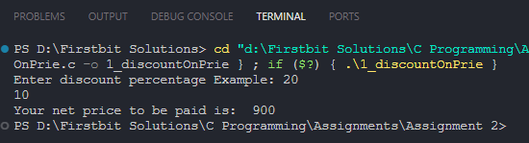

Q2) Find Greatest of 3 using nested if

*#include*<stdio.h>

int main(){

    int a,b,c;

    printf("Enter the value of a: ");

    scanf("%d",*&*a);

    printf("Enter the value of b: ");

    scanf("%d",*&*b);

    printf("Enter the value of c: ");

    scanf("%d",*&*c);

*if*(a*>*b){

*if* (a*>*c)

        {

            printf("A is Greatest of three.");

        }

*else*

        {

            printf("C is Greatest of three.");

        }

    } *else* {

*if*(b*>*c){

            printf("B is Greatest of three.");

        }

*else* {

            printf("C is Greatest of three.");

        }

    }

*return* 0;

}

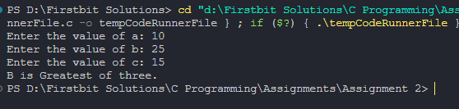

Q3) Accept two numbers from user and an operator (+,-,/,*,%) based on that perform the desired operations.

*#include* <stdio.h>

int main()

{

    int num1, num2;

    char operator;

    printf("Enter the value of number 1: ");

    scanf("%d", *&*num1);

    printf("Enter the value of number 2: ");

    scanf("%d", *&*num2);

    printf("------Enter your choice :------\n");

    printf("For Addition enter '+'\n");

    printf("For Subtraction enter '-'\n");

    printf("For Multiplication enter '*'\n");

    printf("For Divivsion enter '/'\n");

    printf("For Modulo enter '*%*'\n");

    fflush(stdin);

    scanf("%c", *&*operator);

*if* (operator*==* '+')

    {

        printf("%d %c %d = %d", num1, operator, num2, num1 *+* num2);

    }

*else* *if* (operator*==* '-')

    {

        printf("%d %c %d = %d", num1, operator, num2, num1 *-* num2);

    }

*else* *if* (operator*==* '*')

    {

        printf("%d %c %d = %d", num1, operator, num2, num1 *\** num2);

    }

*else* *if* (operator*==* '/')

    {

        printf("%d %c %d = %d", num1, operator, num2, num1 */* num2);

    }

*else* *if* (operator*==* '%')

    {

        printf("%d %c %d = %d", num1, operator, num2, num1 *%* num2);

    }

*return* 0;

}

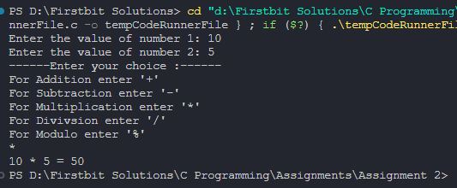

Q4) Display a menu to the user (like 1.Even Odd 2. Basic salary etc), ask the user to enter his choice, then based on that perform the desired operations.

*#include* <stdio.h>

int main()

{

    int choiceNum;

    printf("----Choices-----\n");

    printf("Enter 1 for calculate Even odd\n");

    printf("Enter 2 for calculate Salary\n");

    scanf("%d", *&*choiceNum);

*if* (choiceNum *==* 1)

    {

        int num;

        printf("Enter number to check weather number is even or odd.\n");

        scanf("%d", *&*num);

        num *%* 2 *?* printf("%d is Odd Number\n", num) *:* printf("%d is Even number\n", num);

    }

*else*

    {

        float basic;

        printf("Enter Basic salary\n");

        scanf("%f", *&*basic);

        float salary;

*if* (basic *<=* 5000)

        {

            salary *=* basic *+* (basic *\** 10) */* 100 *+* (basic *\** 20) */* 100 *+* (basic *\** 30) */* 100;

        }

*else*

            salary *=* basic *+* (basic *\** 15) */* 100 *+* (basic *\** 25) */* 100 *+* (basic *\** 30) */* 100;

        printf("Salary is %.2f\n", salary);

    }

*return* 0;

}

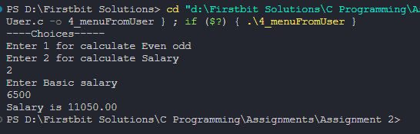

Q5) Accept the price from user. Ask the user if he is a student (user may say yes or no). If he is a student and he has purchased more than 500 than discount is 20% otherwise discount is 10%. But if he is not a student then if he has purchased more than 600 discount is 15% otherwise there is not discount.

*#include* <stdio.h>

int main()

{

    char isStudent;

    float price;

    int discount;

    printf("\nEnter price: ");

    scanf("%f", *&*price);

    printf("If your are student than press 'Y', else press 'N'\n");

    fflush(stdin);

    scanf("%c", *&*isStudent);

*// check validation*

*if*(isStudent*==*'y' *||* isStudent*==*'Y'){

        discount *=* price *>* 500 *?* 20 *:* 10;

    }

*else* *if*(isStudent*==*'n' *||* isStudent*==*'N'){

        discount *=* price *>* 600 *?* 15 *:* 0;

    }

*else*{

        printf("Invalid choice for student elligibility\n");

*return* 0;

    }

    printf("You got %d*\%* Discount\n", discount);

    printf("You have to pay %.2f rs.\n", price *-* (price *\** discount) */* 100);

*return* 0;

}

